**TEST CASES FOR**

**REAL-TIME VIRTUAL DRAWING AND CAPTIONS FOR ONLINE LEARNING USING COMPUTER VISION**

**Test Case 01: Verify Hand Detection and Landmarks**

* **Objective:** Ensure that the application detects hands and displays landmarks correctly.
* **Preconditions:**
  1. Webcam is initialized and functional.
  2. Mediapipe is properly installed.
* **Steps to Execute:**
  1. Run the application.
  2. Place your hand in front of the webcam.
  3. Observe the landmarks and hand connections displayed on the screen.
  4. Move your hand around to check the detection consistency.
* **Actual Result:** Hands and Landmarks detected correctly.

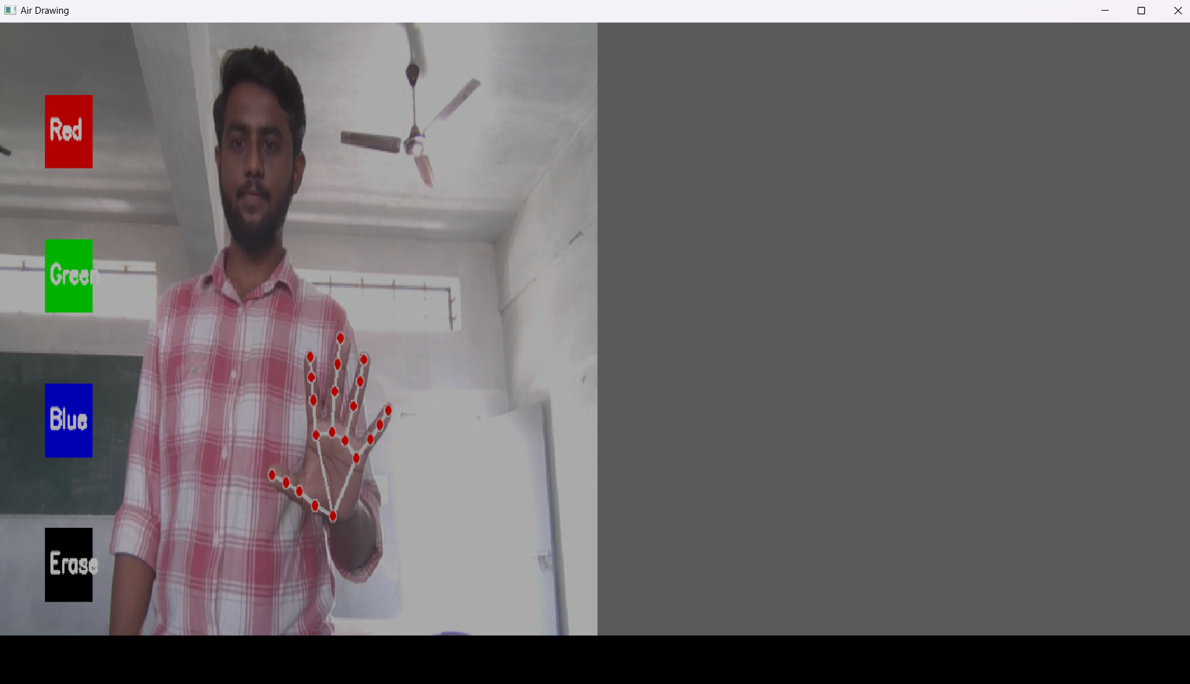

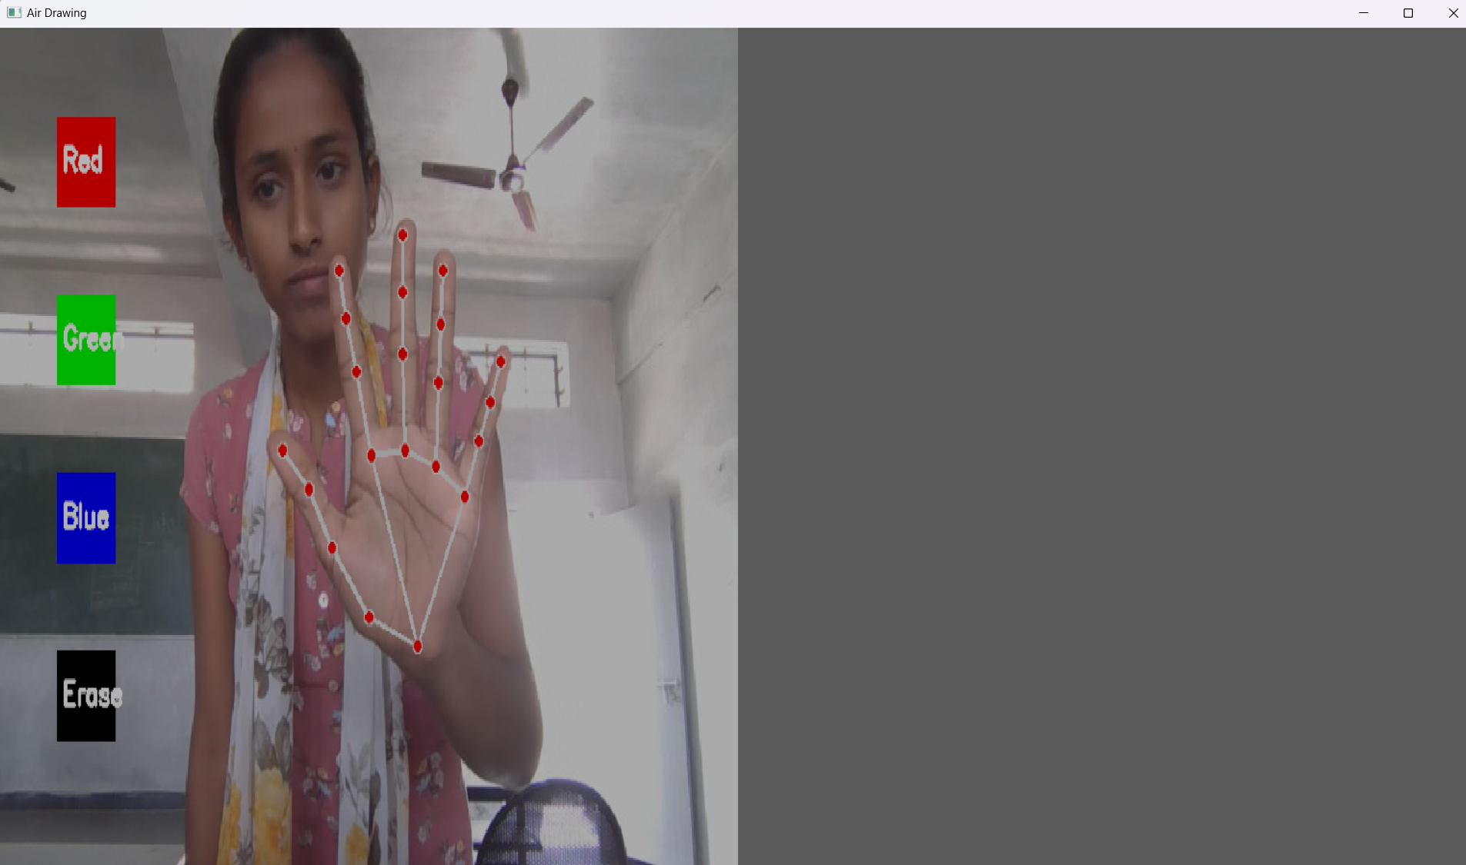

**Test Case 02: Ensure the application can draw on the canvas with the default color (green).**

* **Objective:** Ensure the application can draw on the canvas with the default color (green).
* **Preconditions:**
  1. Webcam is initialized and functional.
  2. Mediapipe is properly installed.
* **Steps to Execute:**
  1. Run the application.
  2. Place your hand in front of the webcam.
  3. Use the index finger to draw on the canvas.
  4. Verify the output on the canvas screen.
* **Actual Result:** Application able to draw on canvas with Green Color.

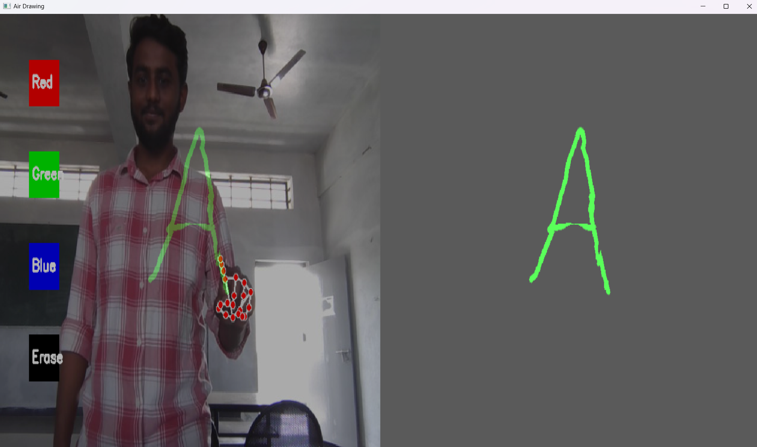

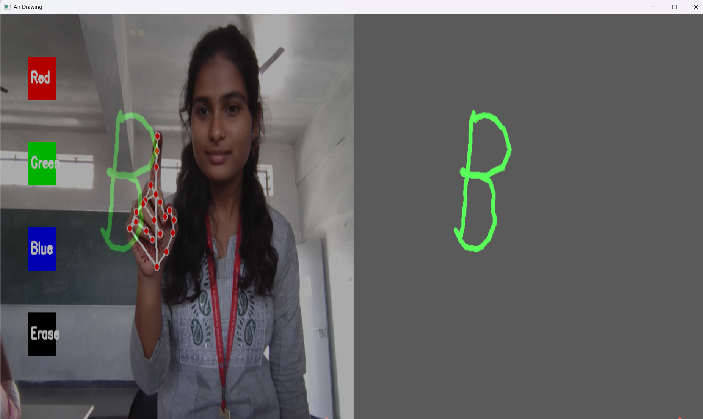

**Test Case 03: Verify Color Selection (Red, Green, Blue)**

* **Objective:** Ensure color buttons change the drawing color.
* **Preconditions:** Application is running and the hand is detected
* **Steps to Execute:**
  1. Draw using the default green color.
  2. Hover the index finger over the "Red" button and verify the color change.
  3. Repeat for the "Blue" button.
  4. Draw again with each selected color and verify the output.
* **Actual Result:** Drawing color should change with respective color buttons.

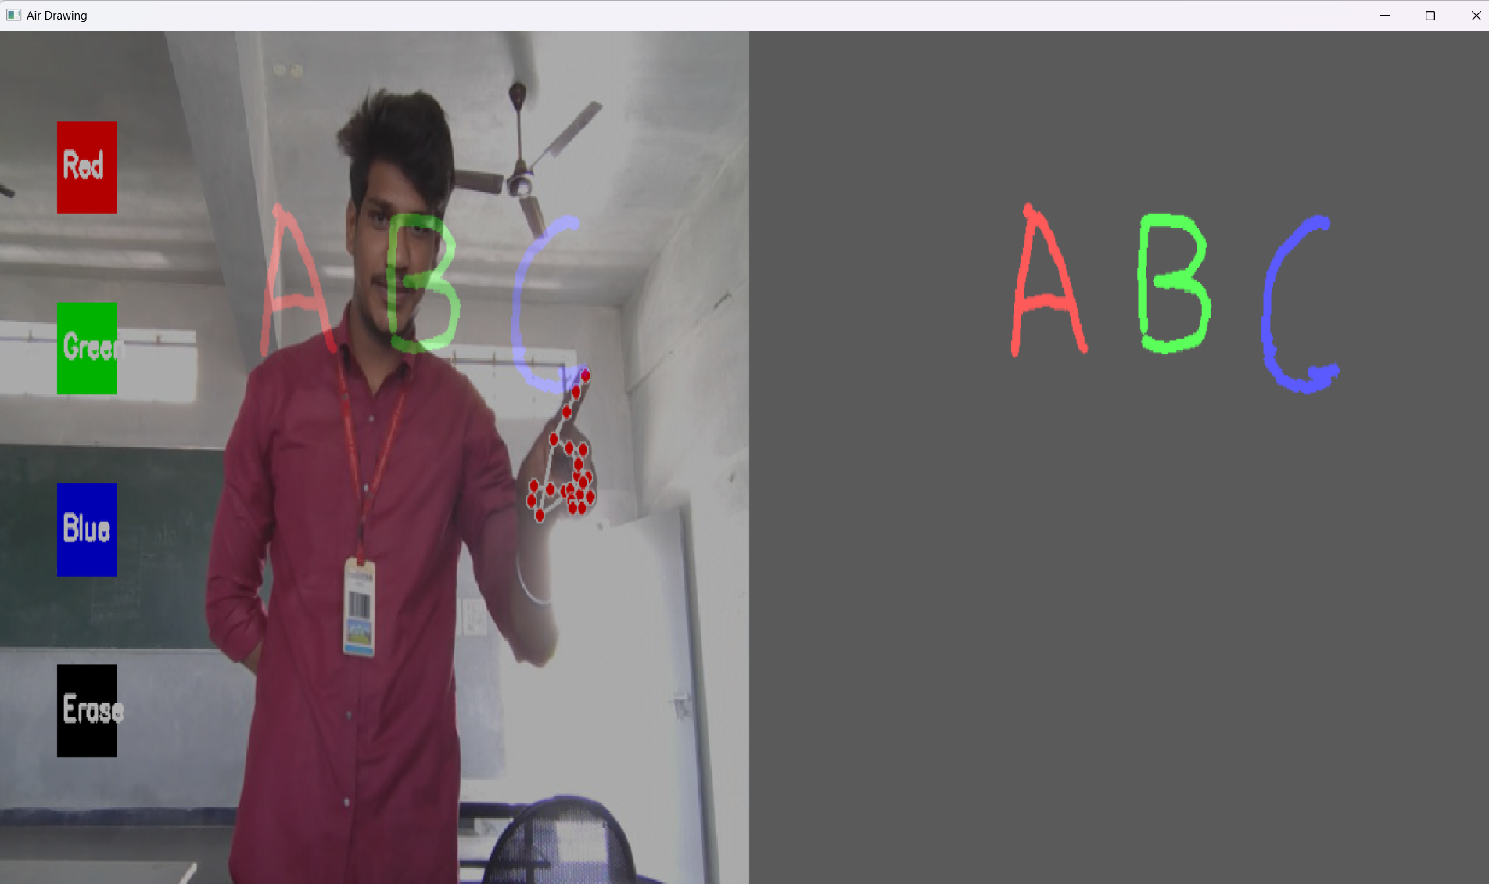

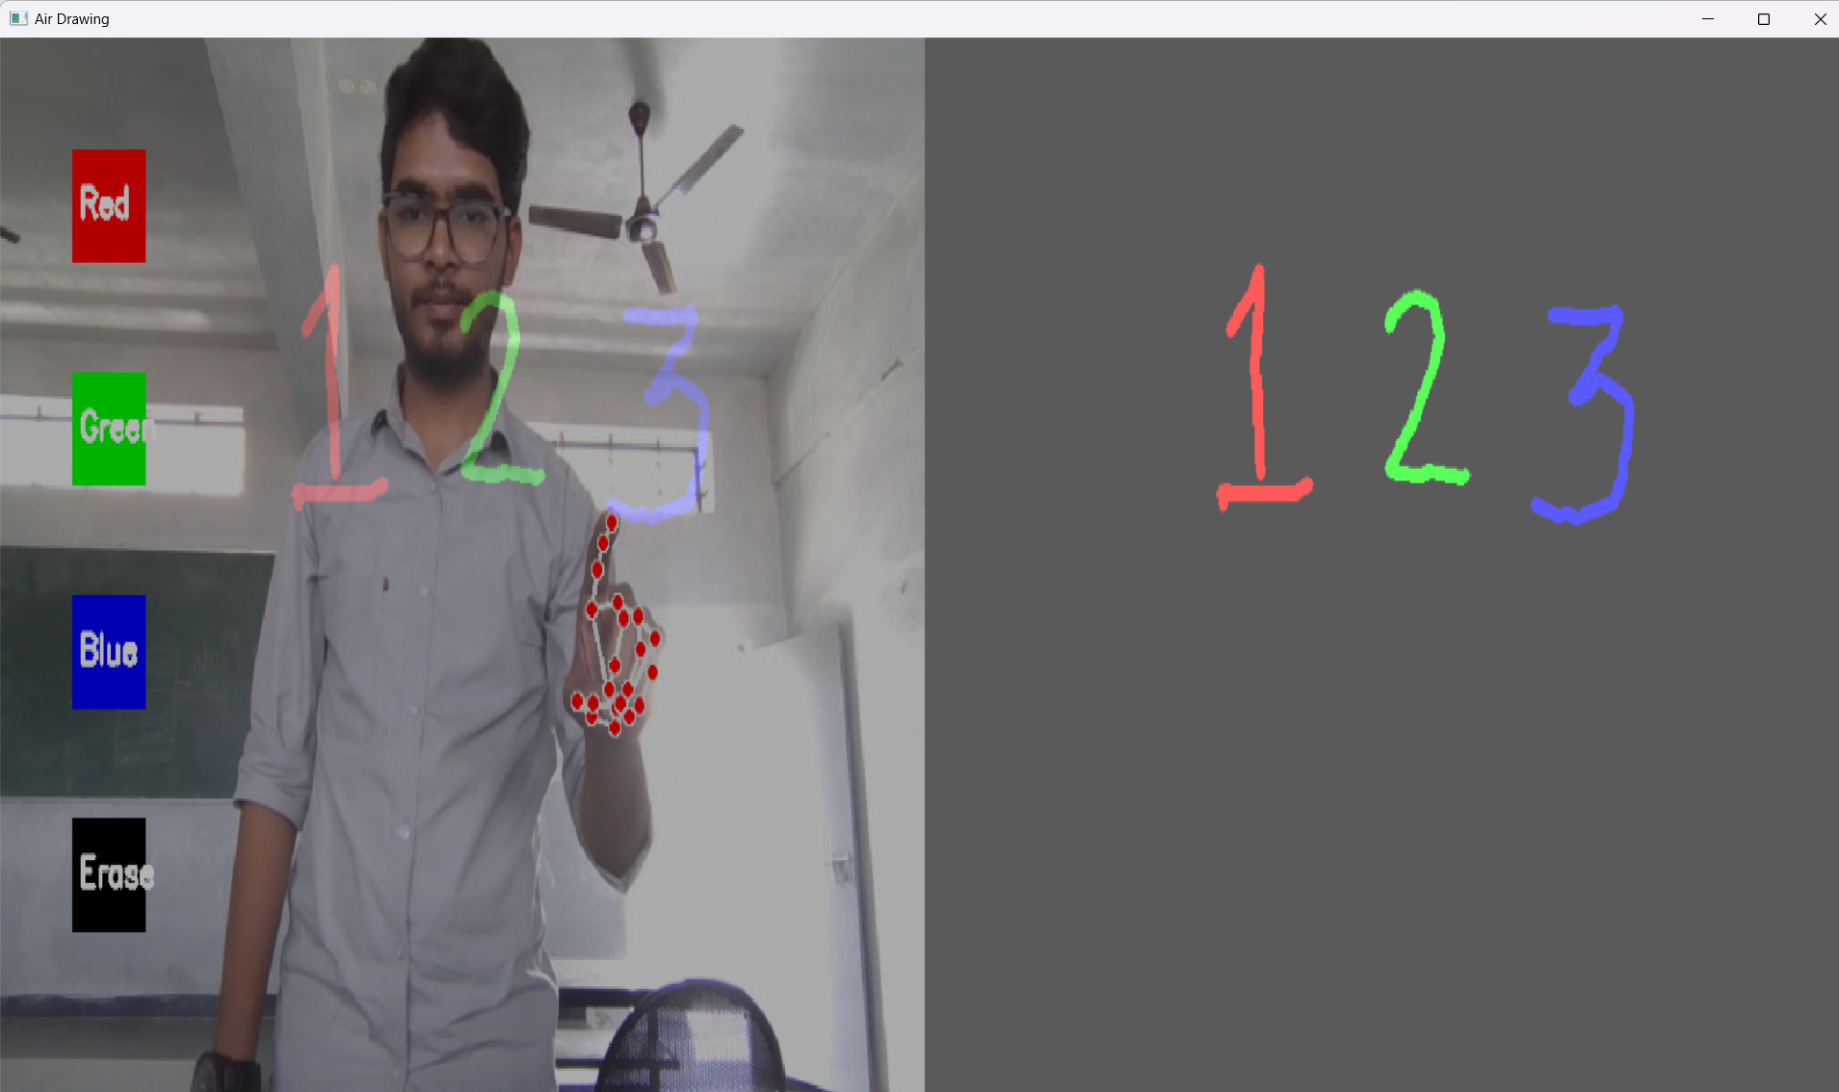

**Test Case 04: Verify Erase Button Functionality**

* **Objective:** Ensure that the "Erase" button clears the canvas.
* **Preconditions:**
  1. Application is running.
  2. Some drawing is already made on the screen.
* **Steps to Execute:**
  1. Draw on the Canvas using any color.
  2. Hover over the “Erase” Button.
* **Result:** The complete canvas is cleared and erased.

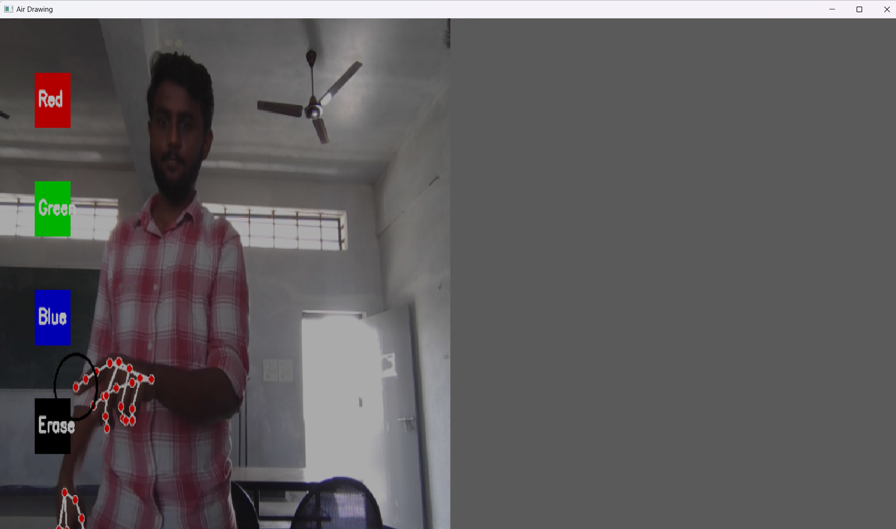

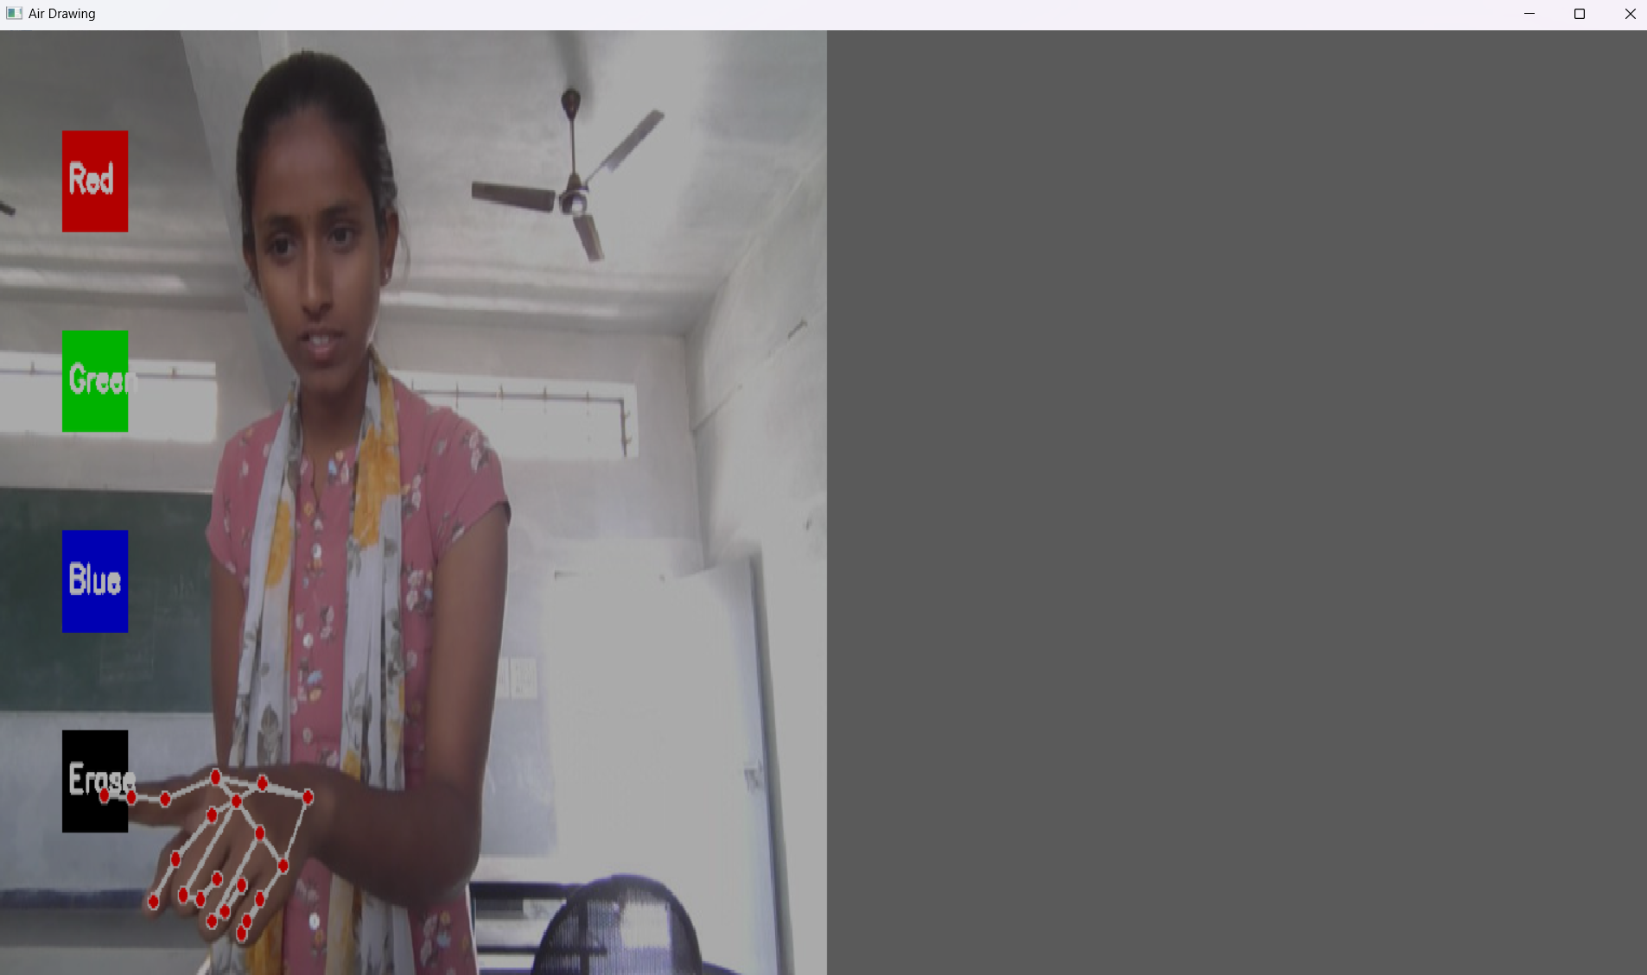

**Test Case 05: Verify Fist Gesture for Erasing**

* **Objective:** Ensure that the fist gesture erases part of the drawing.
* **Preconditions:**
  1. Application is running.
  2. Some drawing is already made on the screen.
* **Steps to Execute:**
  1. Draw on the Canvas using any color.
  2. Make a fist gesture in front of the camera.
  3. Move the fist gesture across the drawing and verify that it erases a part of drawing.
* **Result:** The part of drawing over which fist gesture is made is erased.

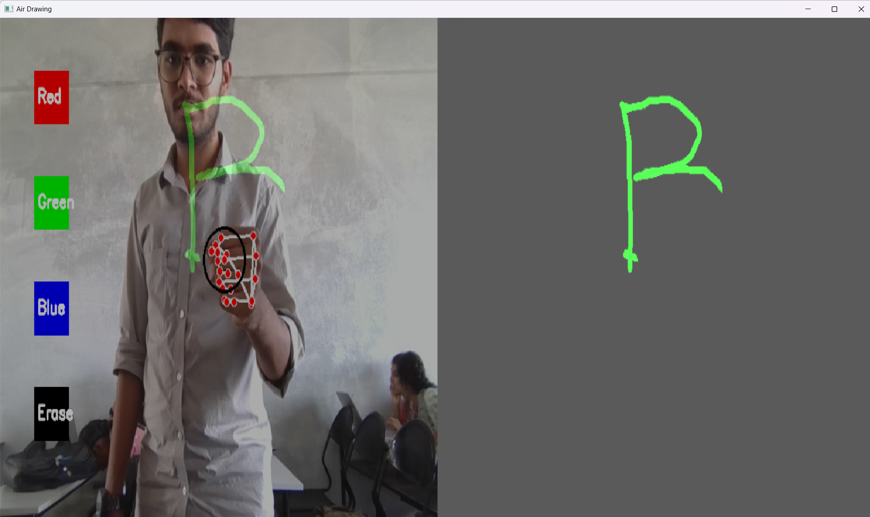

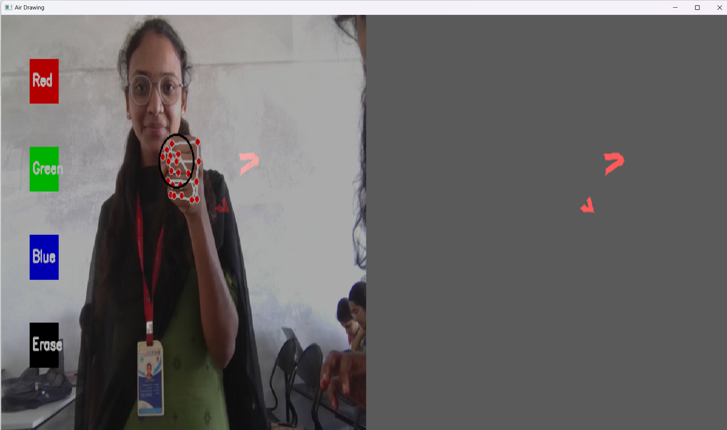

**Test Case 06: Verify Speech-to-Text Captions for Male Voice**

* **Objective:** Ensure that speech is converted to text and displayed as captions.
* **Preconditions:** Microphone is functional, and the application is running
* **Test Data:** Speak "Good Morning, welcome to the Class."
* **Steps to Execute:**
  1. Run the Application.
  2. Speak the test data in the microphone.
  3. Verify whether the text caption appears on the camera screen.
* **Result:** The test caption is displayed on the screen.

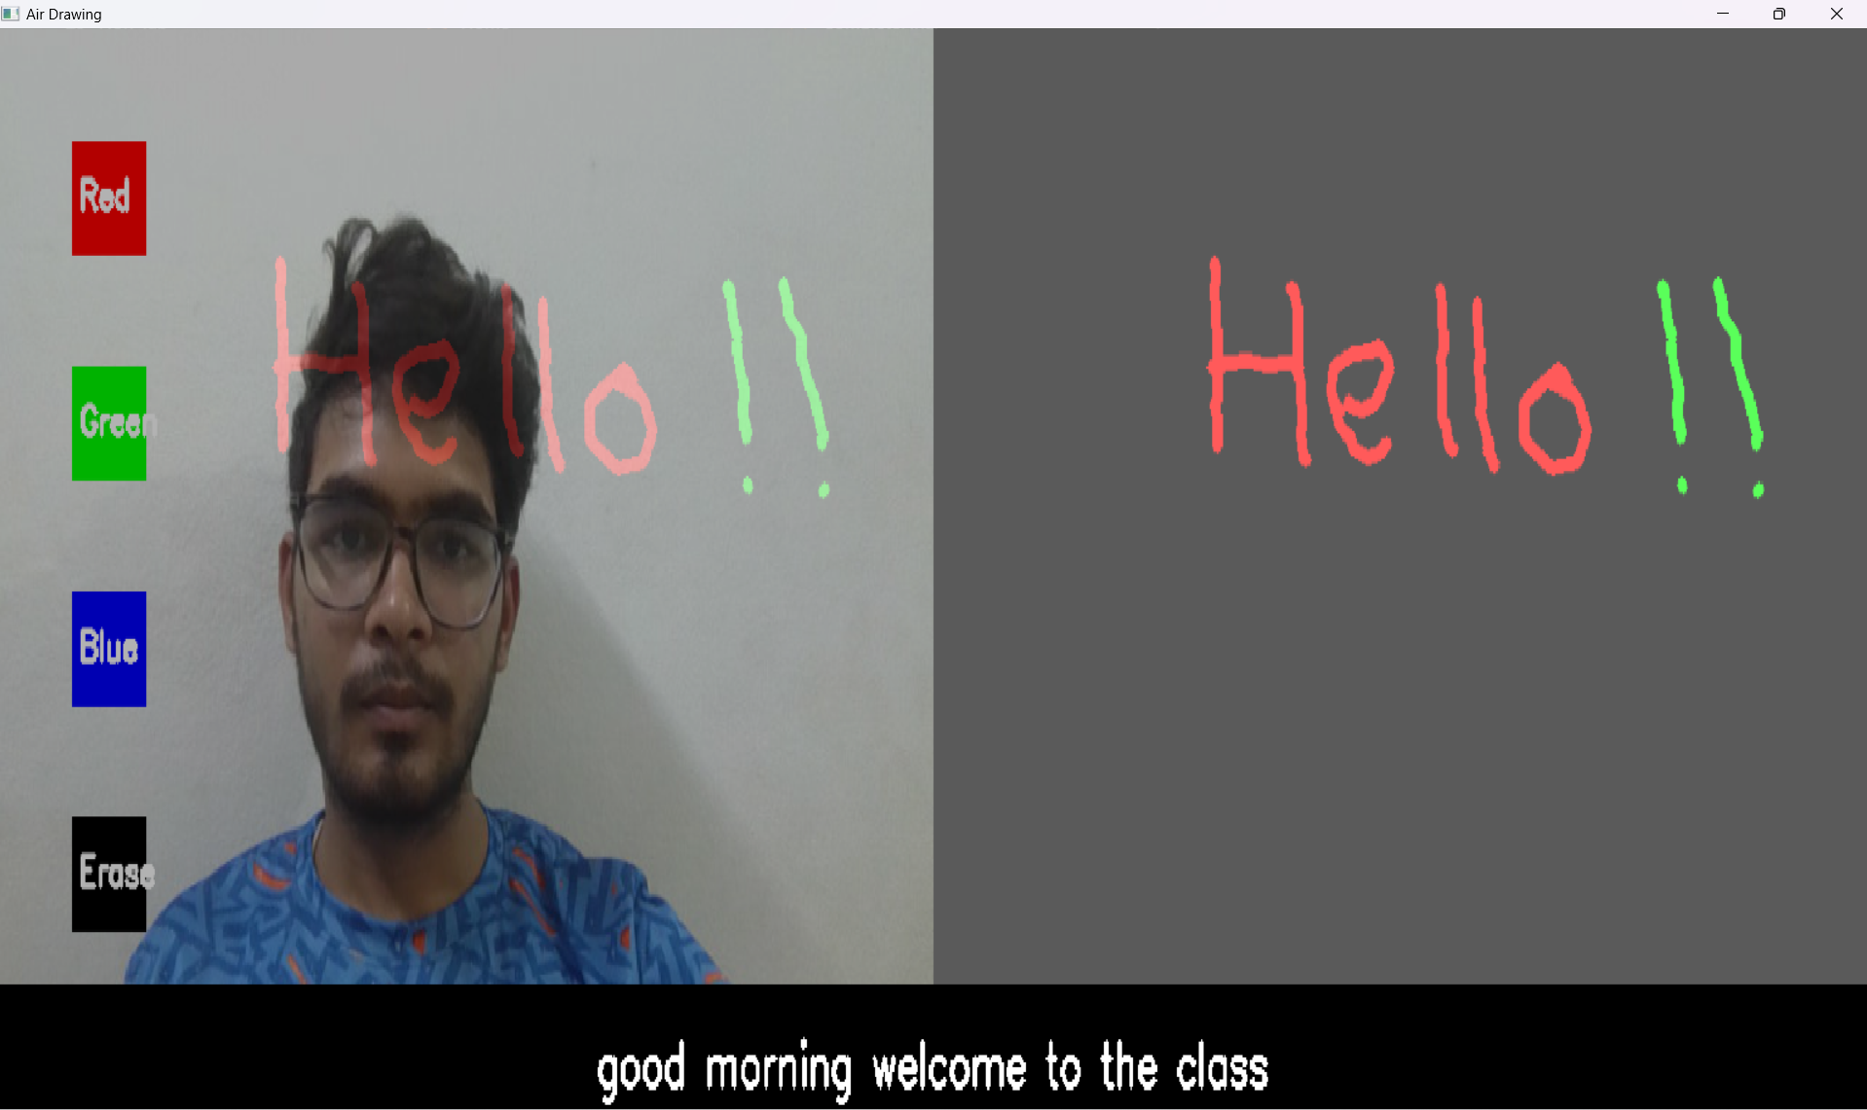

**Test Case 07: Verify Speech-to-Text Captions for Female Voice**

* **Objective:** Ensure that speech is converted to text and displayed as captions.
* **Preconditions:** Microphone is functional, and the application is running
* **Test Data:** Speak "once more."
* **Steps to Execute:**
  1. Run the Application.
  2. Speak the test data in the microphone.
  3. Verify whether the text caption appears on the camera screen.
* **Result:** The test caption is displayed on the screen.

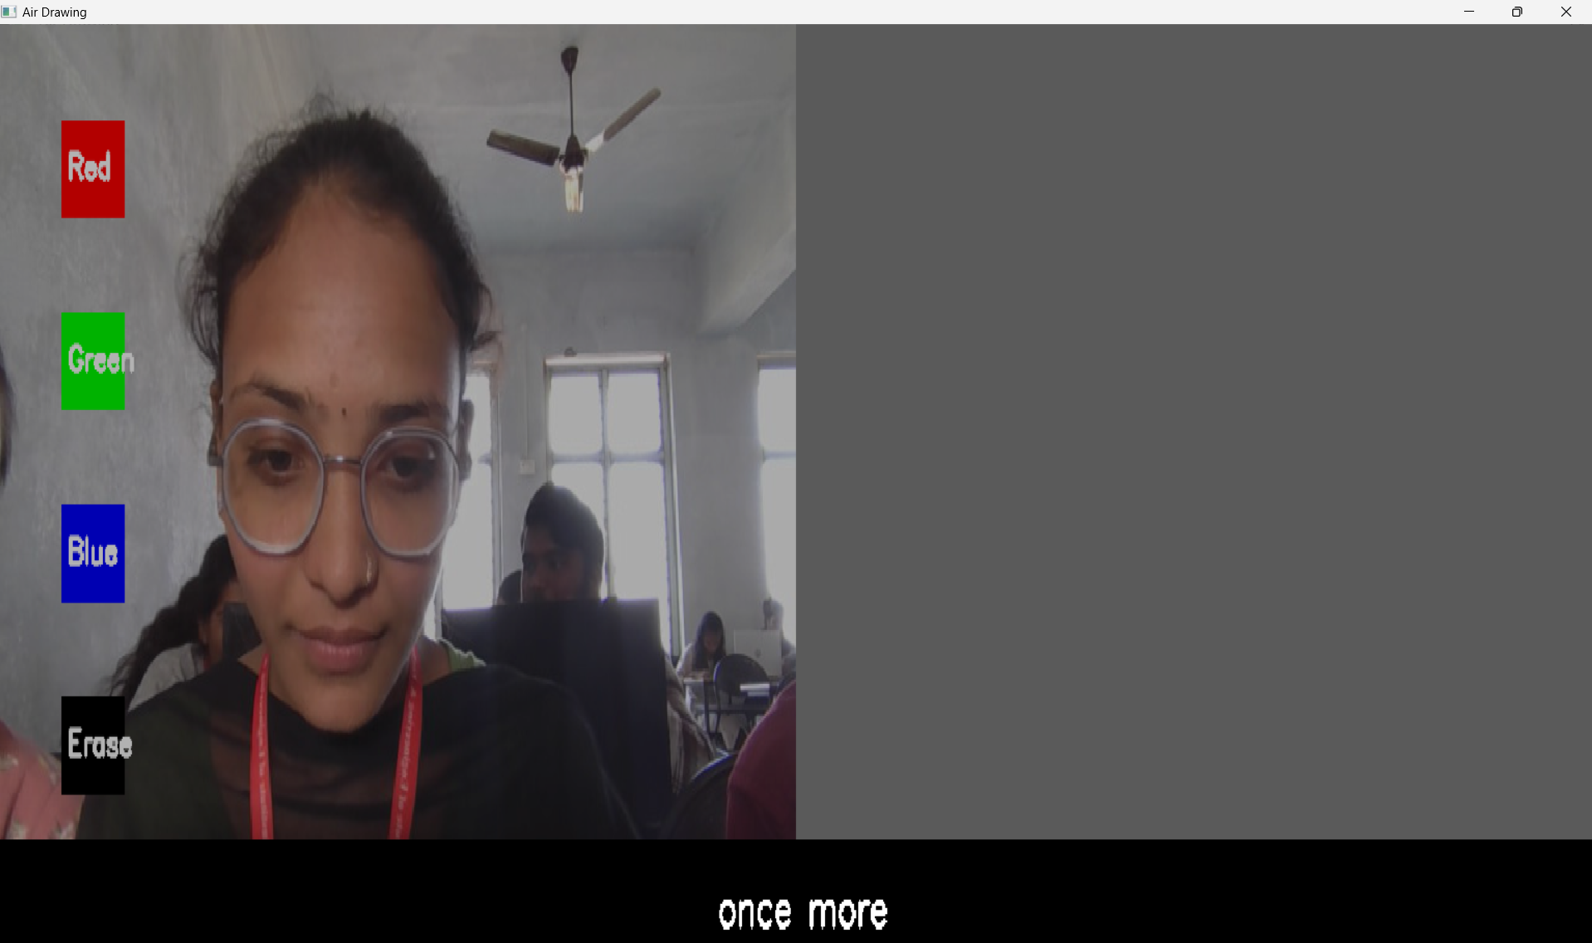

**Test Case 08: Verify Saving the Drawing**

* **Objective:** Ensure that the drawing can be saved as an image file.
* **Preconditions:** Application is running with a drawing on the canvas.
* **Test Data:** Press the **s** key.
* **Steps to Execute:**
  1. Draw on the Canvas.
  2. Press the **s** key to save the drawing.
  3. Check the saved image file in the application directory.
* **Result:** The canvas is saved as image file in the application directory.

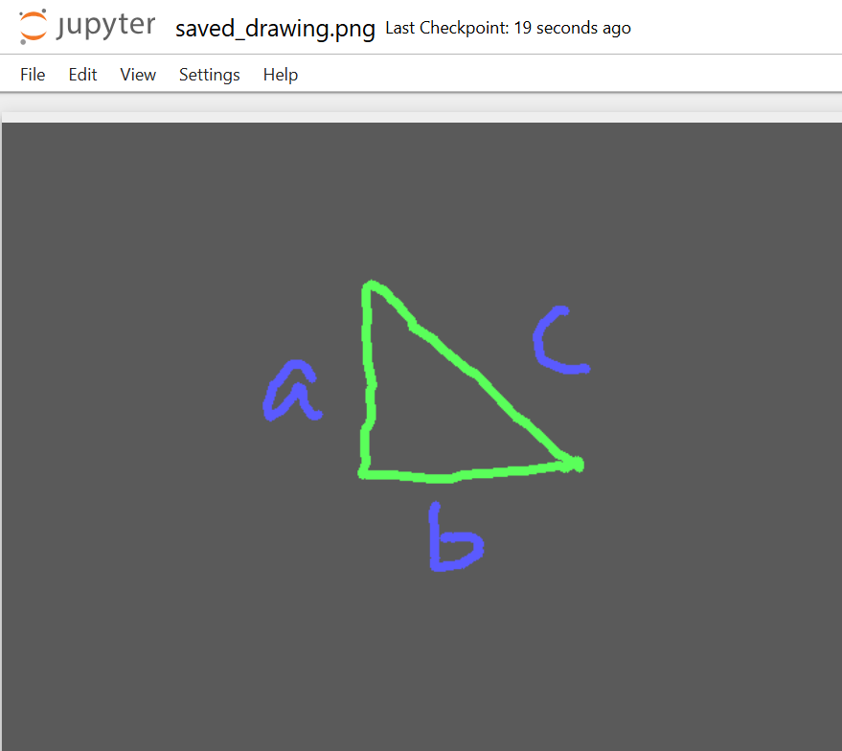

**Test Case 09: Verify Exiting the Drawing Application.**

* **Objective:** Ensure that the drawing can be exited effectively.
* **Preconditions:** Application is running with a drawing on the canvas.
* **Test Data:** Press the **q** key.
* **Steps to Execute:**
  1. Open on the Canvas Application.
  2. Press the **q** key to exit.
  3. The application is closed.
* **Result:** The application is closed on pressing the **q** key.

